**Experiment No. 3**

**Aim:** Create application for demonstration of android activity life cycle.

**Program:**

`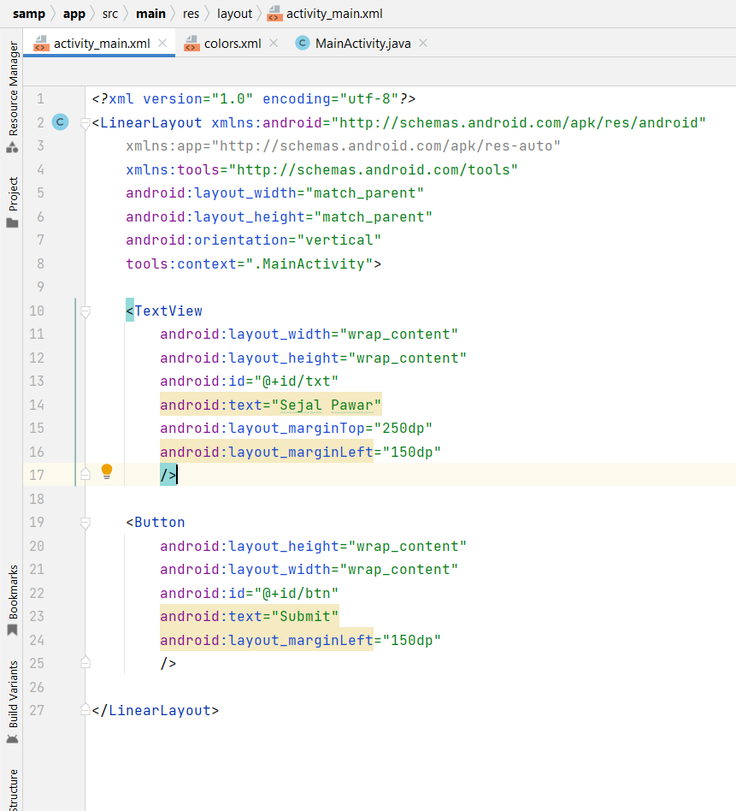

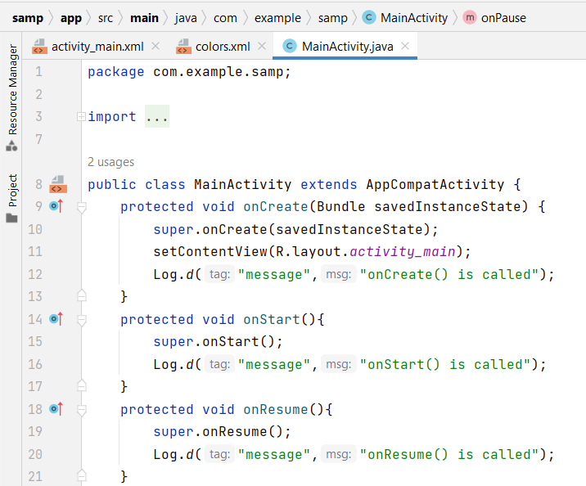

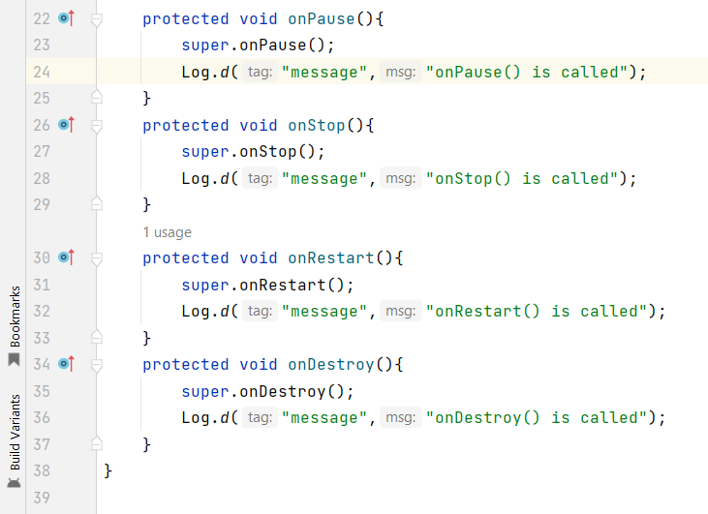

**Output:**

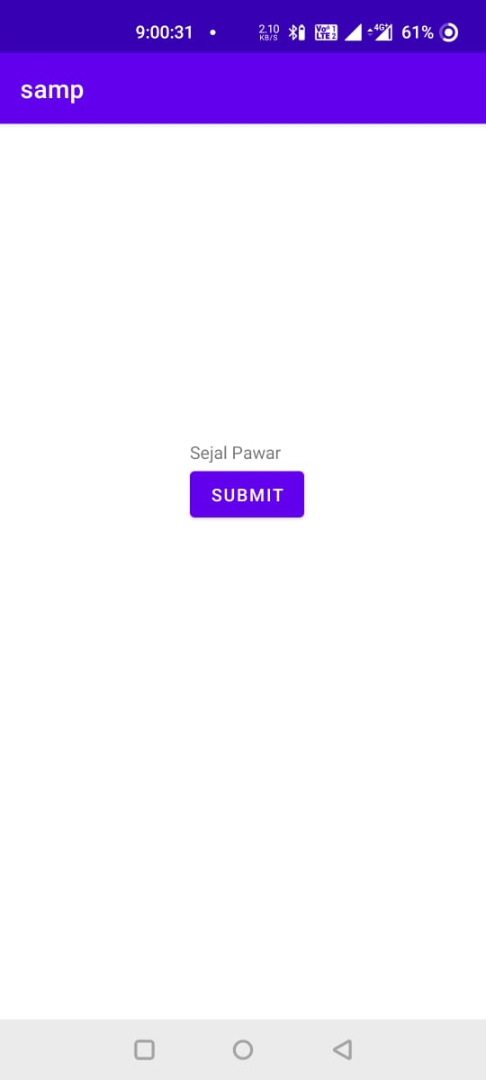

****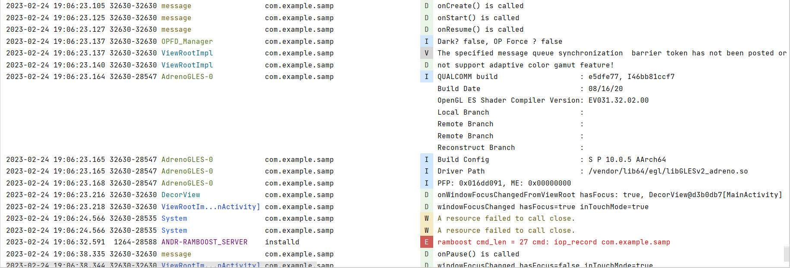



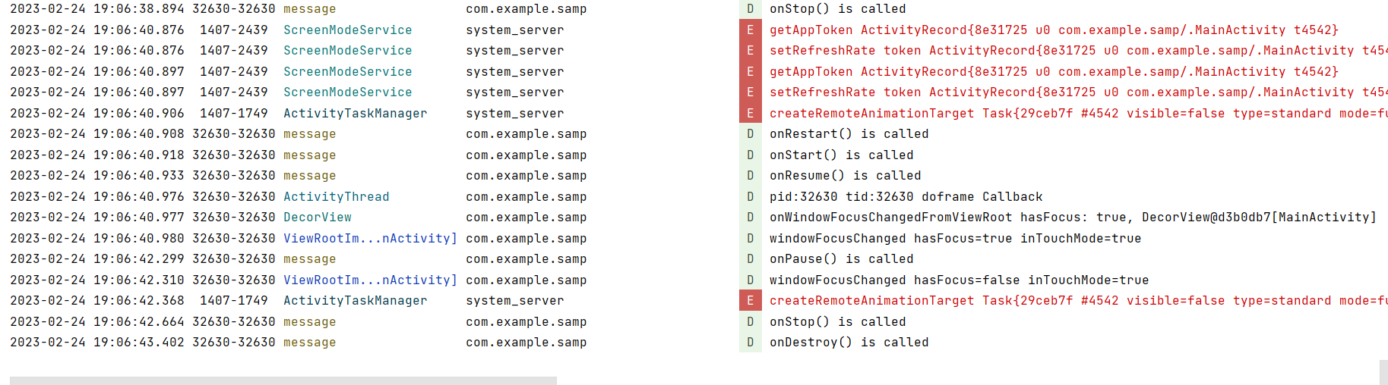



**Conclusion:**

Hence, by completing this experiment I came to know that how to Create application for demonstration of android activity life cycle.

|  |  |  |  |
| --- | --- | --- | --- |
| **Writeup & Oral**  **(4)** | **Practical Performance**  **(4)** | **Attendance**  **(2)** | **Total**  **(10)** |
|  |  |  |  |